November 20, 2016 Faith Baptist Church
Brett Blair, Associate Pastor, Students and Families

Living an "Ordinary" Life with Extraordinary Significance
Colossians 3:1-17

Colossians 3:1

Romans 8:11

New Life in Christ means we gain...

1. A New _______________________
(Colossians 3:1-4)

2. A New ________________________
(Colossians 3:5-8, 2 Corinthians 5:17)

3. A New ________________________
(Colossians 3:9-14, Luke 9:23)

4. A New _________________________
(Colossians 3:15-17)

November 20, 2016 Faith Baptist Church
Brett Blair, Associate Pastor, Students and Families

Living an "Ordinary" Life with Extraordinary Significance
Colossians 3:1-17

Colossians 3:1

Romans 8:11

New Life in Christ means we gain...

1. A New _______________________
(Colossians 3:1-4)

2. A New ________________________
(Colossians 3:5-8, 2 Corinthians 5:17)

3. A New ________________________
(Colossians 3:9-14, Luke 9:23)

4. A New _________________________
(Colossians 3:15-17)

Join us this Christmas
season as we celebrate the
King of Kings!

December 10th & 11th, 6:00pm
Christmas Concert of Praise

December 18th, 5:30pm
“Happy Birthday Jesus” Family Night

December 24th, 5:30pm
Christmas Eve Candlelight Service

December 25th, 10:00am
One Worship Service

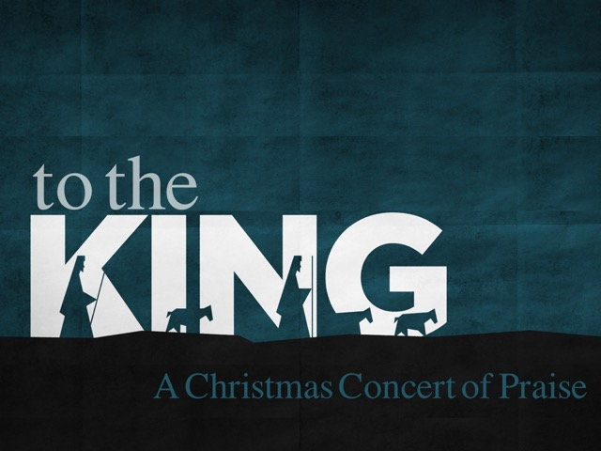

Join us this Christmas
season as we celebrate the
King of Kings!

December 10th & 11th, 6:00pm
Christmas Concert of Praise

December 18th, 5:30pm
“Happy Birthday Jesus” Family Night

December 24th, 5:30pm
Christmas Eve Candlelight Service

December 25th, 10:00am
One Worship Service

