Christmas 2016 Faith Baptist Church
Matt Culbertson, Senior Pastor

"Peace on Earth"
Luke 2:1-14

The Christmas Message

- Favor of God on Mary and Joseph
(Luke 1:28-31)

- Comfort of God's presence and power
(Luke 1:28, 37)

- Mary and Joseph's faithfulness to obey God
(Luke 1:38, Matthew 1:24-25)

- Sovereignly fulfilled birth of Jesus
(Isaiah 7:14)

- Jesus our _______________, Christ the Lord!
(Luke 2:11-14)

Peace on Earth
(Isaiah 9:6; Luke 2:14; Colossians 1:21)

1. Christmas means that we can receive
_________________________________.
(Luke 1:67-79; Romans 5:1, 5-6, 8-11; 2 Corinthians 5:17-19, 21)

2. Christmas means that we can live with the ______________________________.
(John 14:27; 16:33; 2 Corinthians 5:21; Philippians 4:4-9; Isaiah 26:3)

Christmas 2016 Faith Baptist Church
Matt Culbertson, Senior Pastor

"Peace on Earth"
Luke 2:1-14

The Christmas Message

- Favor of God on Mary and Joseph
(Luke 1:28-31)

- Comfort of God's presence and power
(Luke 1:28, 37)

- Mary and Joseph's faithfulness to obey God
(Luke 1:38, Matthew 1:24-25)

- Sovereignly fulfilled birth of Jesus
(Isaiah 7:14)

- Jesus our _______________, Christ the Lord!
(Luke 2:11-14)

Peace on Earth
(Isaiah 9:6; Luke 2:14; Colossians 1:21)

1. Christmas means that we can receive
_________________________________.
(Luke 1:67-79; Romans 5:1, 5-6, 8-11; 2 Corinthians 5:17-19, 21)

2. Christmas means that we can live with the ______________________________.
(John 14:27; 16:33; 2 Corinthians 5:21; Philippians 4:4-9; Isaiah 26:3)

Join us this Christmas
season as we celebrate the
King of Kings!

December 25th, 10:00am
One Worship Service

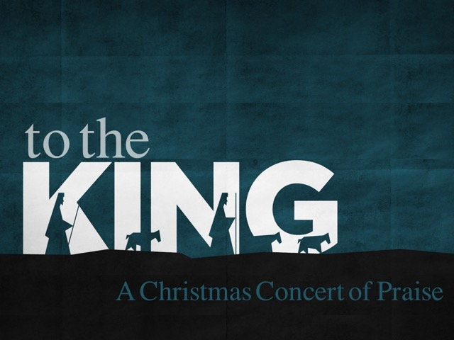

Join us this Christmas
season as we celebrate the
King of Kings!

December 25th, 10:00am
One Worship Service

