December 3, 2017 Faith Baptist Church

Romans: The Gospel of Grace Matt Culbertson, Senior Pastor

**"God's Authority"**

**Romans 13**

**How do we live out the Gospel?**

(Romans 12:1, 3, 9)

**\* Surrender and submission to God will mean that we submit to God**

**given authority in our lives.**

(Romans 13:1-2; 1 Peter 2:13-15)

**1. We must acknowledge that civil authority is God ________________.**

(Exodus 20:13-17; 21:24; 22:1; Romans 13:3-7)

**2. We must recognize that sometimes God's moral law and man's civil**

**law __________________.**

(Romans 13:3, 11-12; Acts 4:13-20; 1 Peter 3:13-17)

**3. We must allow God to live in and through our lives for His**

**__________________.**

(Romans 12:21; 13:14; Matthew 5:10-16; 1 Timothy 2:1-3; Romans 13:8-19)

**But put on the Lord Jesus Christ, and make no provision for the flesh, to fulfill its lusts. Romans 13:14**

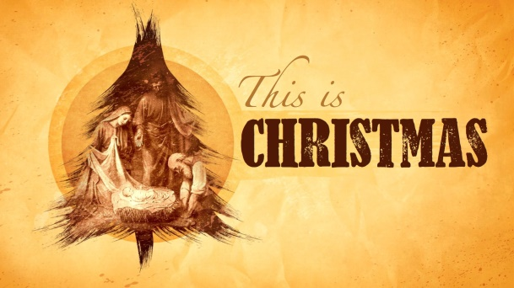

**Christmas Schedule**

**His Kidz Family Service Project**

TONIGHT at 5:30pm

**His Kidz Family Night**

Sunday, December 10, 5:30 pm

**"This is Christmas" A Concert of Praise**

Saturday, December 16, 6:00 pm

Sunday, December 17, 6:00 pm

**Christmas Eve Service**

Sunday Morning, December 24, 9:15 am & 10:45 am