December 4, 2016 Faith Baptist Church
The Holy Spirit - Indwelling and Empowering Matt Culbertson, Senior Pastor

"The Fruit of Love"
Galatians 5:16-25

"God in three persons, blessed Trinity"
(Psalm 19:1; Psalm 8:4-5)

- God with us; ________________
(Matthew 1:23; Colossians 2:9)

- God in us; _____________________
(John 14:16-17)

Baptism by the Spirit = Salvation ________ Christ

Filling of the Spirit = Submitting _________________ to Christ

Walking in the Spirit = Daily surrendering our lives ____________ Christ
(Galatians 5:16-25)

The Fruit of the Spirit is ______________. . .
(Philippians 1:6; Ephesians 2:8-10; 1 John 4:9-11)

1. God loves _____________!
(John 3:16; Romans 5:8; Matthew 22:37-40)

2. Our lives are to bear a supernatural love for _____________.
(1 John 4:7-8; 1 Corinthians 13:1-8; John 15:13)

- Love is patient and ________________.
- Love ___________ ___________ seek its own.
- Love rejoices in _______________.

What kind of Jesus do people see in me?
(John 13:35)

December 4, 2016 Faith Baptist Church
The Holy Spirit - Indwelling and Empowering Matt Culbertson, Senior Pastor

"The Fruit of Love"
Galatians 5:16-25

"God in three persons, blessed Trinity"
(Psalm 19:1; Psalm 8:4-5)

- God with us; ________________
(Matthew 1:23; Colossians 2:9)

- God in us; _____________________
(John 14:16-17)

Baptism by the Spirit = Salvation ________ Christ

Filling of the Spirit = Submitting _________________ to Christ

Walking in the Spirit = Daily surrendering our lives ____________ Christ
(Galatians 5:16-25)

The Fruit of the Spirit is ______________. . .
(Philippians 1:6; Ephesians 2:8-10; 1 John 4:9-11)

1. God loves _____________!
(John 3:16; Romans 5:8; Matthew 22:37-40)

2. Our lives are to bear a supernatural love for _____________.
(1 John 4:7-8; 1 Corinthians 13:1-8; John 15:13)

- Love is patient and ________________.
- Love ___________ ___________ seek its own.
- Love rejoices in _______________.

What kind of Jesus do people see in me?
(John 13:35)

Join us this Christmas
season as we celebrate the
King of Kings!

December 10th & 11th, 6:00pm
Christmas Concert of Praise

December 18th, 5:30pm
“Happy Birthday Jesus” Family Night

December 24th, 5:30pm
Christmas Eve Candlelight Service

December 25th, 10:00am
One Worship Service

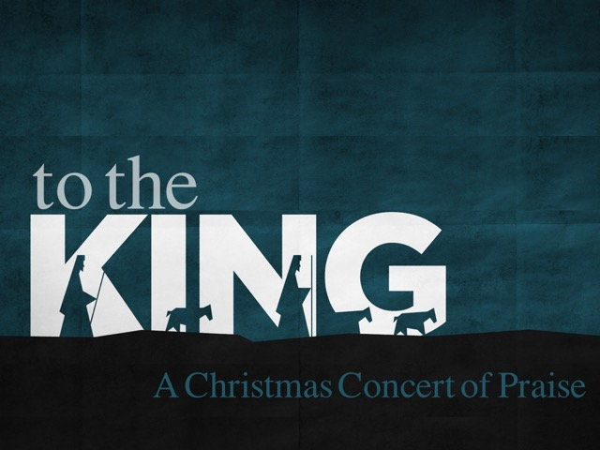

Join us this Christmas
season as we celebrate the
King of Kings!

December 10th & 11th, 6:00pm
Christmas Concert of Praise

December 18th, 5:30pm
“Happy Birthday Jesus” Family Night

December 24th, 5:30pm
Christmas Eve Candlelight Service

December 25th, 10:00am
One Worship Service

