February 28, 2016 Faith Baptist Church
Hebrews: Consider Jesus Matt Culbertson-Senior Pastor

“Enter His Rest”
Hebrews 3-4:13

Discover Jesus!
(Hebrews 3:1-6)

- We must guard against the danger of __________________; understand the lesson from history.
(Hebrews 3:7-11; Numbers 13:30-31; 14:1-4, 20-22)

- Unbelieving ________________
(Hebrews 3:12)

- ____________________ of Sin
(Hebrews 3:13-14)

- Rebellion and___________________ of heart (Hebrews 3:15-17)

- No _______________ for our souls
(Hebrews 3:18-19; Deuteronomy 28:64-65)

- We must _______________ God’s provision for rest.
(Hebrews 4:1-3, 9-10; John 10:10)

- Hold on to ________________
(Hebrews 3:6,14)

- Do not waiver in ___________________
(Hebrews 3:8)

- Watch out and _________________ each other
(Hebrews 3:12-13)

- ____________ and obey His voice
(Hebrews 3:7,15)

- We will remain in His rest by trusting His _______________.
(Hebrews 4:12-13; Matthew 11:28-30)

February 28, 2016 Faith Baptist Church
Hebrews: Consider Jesus Matt Culbertson-Senior Pastor

“Enter His Rest”
Hebrews 3-4:13

Discover Jesus!
(Hebrews 3:1-6)

- We must guard against the danger of ______________; understand the lesson from history.
(Hebrews 3:7-11; Numbers 13:30-31; 14:1-4, 20-22)

- Unbelieving _______________
(Hebrews 3:12)

- __________________of Sin
(Hebrews 3:13-14)

- Rebellion and _________________ of heart
(Hebrews 3:15-17)

- No ___________for our souls
(Hebrews 3:18-19; Deuteronomy 28:64-65)

- We must _________________ God’s provision for rest.
(Hebrews 4:1-3, 9-10; John 10:10)

- Hold on to ________________
(Hebrews 3:6,14)

- Do not waiver in __________________
(Hebrews 3:8)

- Watch out and __________________each other (Hebrews 3:12-13)

- ________________ and obey His voice
(Hebrews 3:7,15)

- We will remain in His rest by trusting His ________________.
(Hebrews 4:12-13; Matthew 11:28-30)

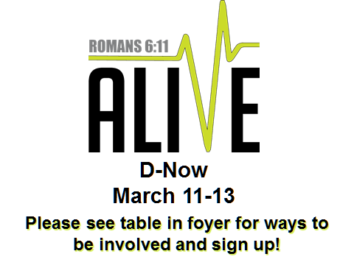
EASTER SCHEDULE

Good Friday Service
March 25th, 6:30 pm

Easter Sunday Morning
March 27th
Worship: 8:00 am
(Activities for children)

Worship/Bible Study: 9:15 and 10:45 am

EASTER SCHEDULE

Good Friday Service
March 25th, 6:30 pm

Easter Sunday Morning
March 27th
Worship: 8:00 am
(Activities for children)

Worship/Bible Study: 9:15 and 10:45 am

