July 10, 2016 Faith Baptist Church
The Lord's Prayer - Connecting With God Matt Culbertson, Senior Pastor

“Connecting with God”
Matthew 6:5-15

Connecting with God
(Matthew 6:8; John 15:4-8; Matthew 6:33)

The Lord's Prayer
(Luke 11:1)

- 3 Words: ___________________, _________________, and ____________________

Why doesn't prayer "work"?

1. When we don't __________________
(Matthew 6:5-9)

2. When our __________________ prayer life is lacking
(Matthew 6:5-6)

3. When we talk and do not ______________________
(Matthew 6:7-8)

- Focus on who _____________ is.
(1Timothy 1:17)

- Pray _____________________ to God.
(Matthew 4:4)

- Pray in __________________ name.
(Hebrews 10:19-20)

4. When our hearts are calloused by _______________
(Matthew 6:14-15)
July 10, 2016 Faith Baptist Church
The Lord's Prayer - Connecting With God Matt Culbertson, Senior Pastor

“Connecting with God”
Matthew 6:5-15

Connecting with God
(Matthew 6:8; John 15:4-8; Matthew 6:33)

The Lord's Prayer
(Luke 11:1)

- 3 Words: ___________________, _________________, and ____________________

Why doesn't prayer "work"?

1. When we don't __________________
(Matthew 6:5-9)

2. When our __________________ prayer life is lacking
(Matthew 6:5-6)

3. When we talk and do not ______________________
(Matthew 6:7-8)

- Focus on who _____________ is.
(1Timothy 1:17)

- Pray _____________________ to God.
(Matthew 4:4)

- Pray in __________________ name.
(Hebrews 10:19-20)

4. When our hearts are calloused by _______________
(Matthew 6:14-15)

Call to Pray
Faith Baptist Church
2016

- July 8 - October 28, Prayer and Fasting Fridays
(Prayer focus sent out each Wednesday, sign-up on Worship Guide tear-off or contact church office.)

- August 11, 7:00-8:00 p.m., Prayer Gathering at Faith Baptist Church. Emphasis on families, children, schools etc.

- September 11, Sunday Morning Worship. Prayer focus for our nation and world.

- October 12, 7:00-8:00p.m., Prayer Gathering at Faith Baptist Church. Emphasis on upcoming election and prayer for revival.
Call to Pray
Faith Baptist Church
2016

- July 8 - October 28, Prayer and Fasting Fridays
(Prayer focus sent out each Wednesday, sign-up on Worship Guide tear-off or contact church office.)

- August 11, 7:00-8:00 p.m., Prayer Gathering at Faith Baptist Church. Emphasis on families, children, schools etc.

- September 11, Sunday Morning Worship. Prayer focus for our nation and world.

- October 12, 7:00-8:00p.m., Prayer Gathering at Faith Baptist Church. Emphasis on upcoming election and prayer for revival.

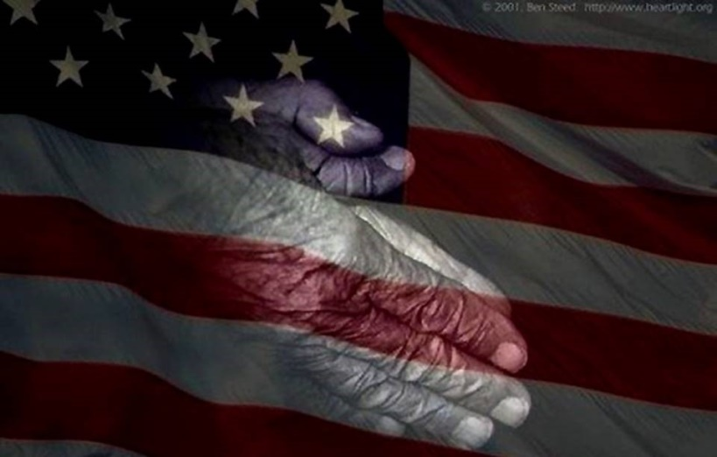
Fundraiser for Summer Student Camp and Mission Trip!
May 22nd, 6:00 pm
An evening of entertainment, fun and fellowship!
Fundraiser for Summer Student Camp and Mission Trip!
May 22nd, 6:00 pm
An evening of entertainment, fun and fellowship!

