July 3, 2016 Faith Baptist Church
Matt Culbertson, Senior Pastor

“For Such a Time as This”
Esther

"The times, they are a changin'," (Bob Dylan)

- How do we live and influence our culture when we are the moral minority?
(Luke 9:23-26)

Esther

1. Seek God in __________________
(Esther 4:1-3, 15-16; Isaiah 58:1,6)

2. Trust God's sovereign _____________________ and provision
(Esther 4:13-14; Genesis 50:20)

3. Live wisely, boldly, and ___________________________
(Esther 2:21-23; 3 :1-4; Matthew 10:16; Esther 4:5-8)

4. Rest in _____________________ to God's holiness and sovereign plan
(Esther 4:14; 5:23; 6:1; Proverbs 3:5-6)

July 3, 2016 Faith Baptist Church
Matt Culbertson, Senior Pastor

“For Such a Time as This”
Esther

"The times, they are a changin'," (Bob Dylan)

- How do we live and influence our culture when we are the moral minority?
(Luke 9:23-26)

Esther

1. Seek God in __________________
(Esther 4:1-3, 15-16; Isaiah 58:1,6)

2. Trust God's sovereign _____________________ and provision
(Esther 4:13-14; Genesis 50:20)

3. Live wisely, boldly, and ___________________________
(Esther 2:21-23; 3 :1-4; Matthew 10:16; Esther 4:5-8)

4. Rest in _____________________ to God's holiness and sovereign plan
(Esther 4:14; 5:23; 6:1; Proverbs 3:5-6)

Call to Pray
Faith Baptist Church
2016

- July 8 - October 28, Prayer and Fasting Fridays
(Prayer focus sent out each Wednesday, sign-up on Worship Guide tear-off or contact church office.)

- August 11, 7:00-8:00 p.m., Prayer Gathering at Faith Baptist Church. Emphasis on families, children, schools etc.

- September 11, Sunday Morning Worship. Prayer focus for our nation and world.

- October 12, 7:00-8:00p.m., Prayer Gathering at Faith Baptist Church. Emphasis on upcoming election and prayer for revival.
Call to Pray
Faith Baptist Church
2016

- July 8 - October 28, Prayer and Fasting Fridays
(Prayer focus sent out each Wednesday, sign-up on Worship Guide tear-off or contact church office.)

- August 11, 7:00-8:00 p.m., Prayer Gathering at Faith Baptist Church. Emphasis on families, children, schools etc.

- September 11, Sunday Morning Worship. Prayer focus for our nation and world.

- October 12, 7:00-8:00p.m., Prayer Gathering at Faith Baptist Church. Emphasis on upcoming election and prayer for revival.

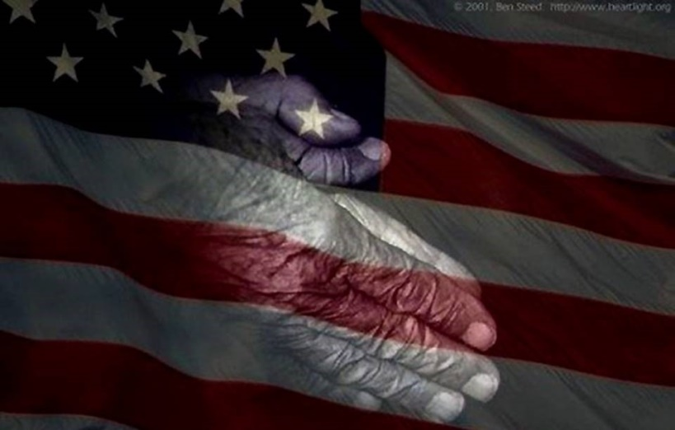
Fundraiser for Summer Student Camp and Mission Trip!
May 22nd, 6:00 pm
An evening of entertainment, fun and fellowship!
Fundraiser for Summer Student Camp and Mission Trip!
May 22nd, 6:00 pm
An evening of entertainment, fun and fellowship!

