December 10, 2017 Faith Baptist Church

Romans: The Gospel of Grace Matt Culbertson, Senior Pastor

**"Selfless Living"**

**Romans 14-15:13**

**How do we live the Gospel of Grace?**

**_________________ and __________________**

(Romans 12:1-3, 16; 13:14-14:1, 7-8)

**\* Selfless living is ______________ living!**

(Luke 9:23; Romans 14:1-3; 15:1-3)

**1. Enjoy the reality of our __________________ in Christ while**

**exercising our freedom _________________, refusing to be a**

**stumbling block.**

(Romans 14:14-15; Galatians 5:1; Romans 14:21-23)

**2. Be ________________ to the Holy Spirit's work in our life but refuse**

**to play the Holy Spirit in _______________.**

(Romans 14:12-13, 20; Ephesians 4:30-32)

**3. Spend our energy on things that promote _______________ and**

**spiritual growth, unleashing God's _______________ in and through**

**our lives.**

(Romans 14:17-19; 15:7-13)

**Next Sunday: "The Cradle to the Cross"**

December 10, 2017 Faith Baptist Church

Romans: The Gospel of Grace Matt Culbertson, Senior Pastor

**"Selfless Living"**

**Romans 14-15:13**

**How do we live the Gospel of Grace?**

**_________________ and __________________**

(Romans 12:1-3, 16; 13:14-14:1, 7-8)

**\* Selfless living is ______________ living!**

(Luke 9:23; Romans 14:1-3; 15:1-3)

**1. Enjoy the reality of our __________________ in Christ while**

**exercising our freedom _________________, refusing to be a**

**stumbling block.**

(Romans 14:14-15; Galatians 5:1; Romans 14:21-23)

**2. Be ________________ to the Holy Spirit's work in our life but refuse**

**to play the Holy Spirit in _______________.**

(Romans 14:12-13, 20; Ephesians 4:30-32)

**3. Spend our energy on things that promote _______________ and**

**spiritual growth, unleashing God's _______________ in and through**

**our lives.**

(Romans 14:17-19; 15:7-13)

**Next Sunday: "The Cradle to the Cross"**

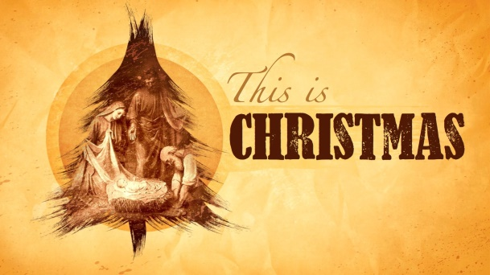

**Christmas Schedule**

**His Kidz Family Night**

Sunday, December 10, 5:30 pm

**"This is Christmas" A Concert of Praise**

Saturday, December 16, 6:00 pm

Sunday, December 17, 6:00 pm

**Christmas Eve Morning Service**

Sunday Morning, December 24, 9:15 am & 10:45 am



**Christmas Schedule**

**His Kidz Family Night**

Sunday, December 10, 5:30 pm

**"This is Christmas" A Concert of Praise**

Saturday, December 16, 6:00 pm

Sunday, December 17, 6:00 pm

**Christmas Eve Morning Service**

Sunday Morning, December 24, 9:15 am & 10:45 am