December 11, 2016 Faith Baptist Church
The Holy Spirit - Indwelling and Empowering Matt Culbertson, Senior Pastor

"The Fruit of Joy"
Galatians 5:22-25

The Fruit of the Spirit...
(Galatians 5:22-25, Ephesians 2:8-10; Ephesians 4:30-5:1; Philippians 1:10-11)

. . . is Love,
(1 John 4:9-11; Matthew 22:37-40; John 13:35)

The Fruit of Joy
(Matthew 2:10; John 15:11; 1 Thessalonians 4:16)

- Joy is inner ___________________, expressed in outward ______________________

1. Recognize Joy________________.
(John 10:10)

- Selfishness (Philippians 2:2-3)
- Bitterness (Colossians 3:13)
- Fear (2 Timothy 1:7)

2. Refuse to settle for ___________________ to true Joy.

- Happiness (Psalm 30:4-5, 11-12)
- Pleasure (Luke 8:14)

3. Rest in the Joy of the _______________.
(Nehemiah 8:10)

- Abide in __________________
(John 15:10-11)

- Worship with __________________
(Psalm 100:1-5)

- Choose _________________
(Hebrews 12:2; 1 John 1:4)

December 11, 2016 Faith Baptist Church
The Holy Spirit - Indwelling and Empowering Matt Culbertson, Senior Pastor

"The Fruit of Joy"
Galatians 5:22-25

The Fruit of the Spirit...
(Galatians 5:22-25, Ephesians 2:8-10; Ephesians 4:30-5:1; Philippians 1:10-11)

. . . is Love,
(1 John 4:9-11; Matthew 22:37-40; John 13:35)

The Fruit of Joy
(Matthew 2:10; John 15:11; 1 Thessalonians 4:16)

- Joy is inner ___________________, expressed in outward ______________________

1. Recognize Joy________________.
(John 10:10)

- Selfishness (Philippians 2:2-3)
- Bitterness (Colossians 3:13)
- Fear (2 Timothy 1:7)

2. Refuse to settle for ___________________ to true Joy.

- Happiness (Psalm 30:4-5, 11-12)
- Pleasure (Luke 8:14)

3. Rest in the Joy of the _______________.
(Nehemiah 8:10)

- Abide in __________________
(John 15:10-11)

- Worship with __________________
(Psalm 100:1-5)

- Choose _________________
(Hebrews 12:2; 1 John 1:4)

Join us this Christmas
season as we celebrate the
King of Kings!

December 10th & 11th, 6:00pm
Christmas Concert of Praise

December 18th, 5:30pm
“Happy Birthday Jesus” Family Night

December 24th, 5:30pm
Christmas Eve Candlelight Service

December 25th, 10:00am
One Worship Service

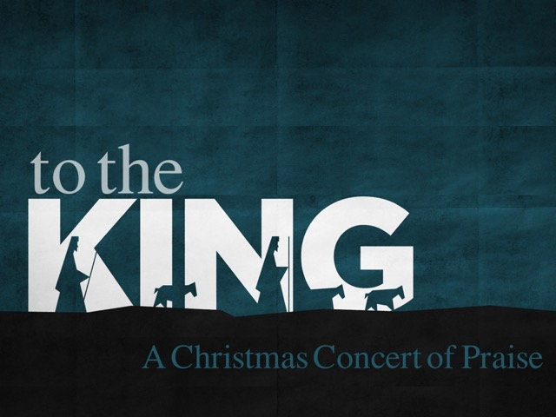

Join us this Christmas
season as we celebrate the
King of Kings!

December 10th & 11th, 6:00pm
Christmas Concert of Praise

December 18th, 5:30pm
“Happy Birthday Jesus” Family Night

December 24th, 5:30pm
Christmas Eve Candlelight Service

December 25th, 10:00am
One Worship Service

