December 17, 2017 Faith Baptist Church

Christmas 2017 Matt Culbertson, Senior Pastor

**"The Cradle and The Cross"**

**Various Scriptures**

**Jesus, The Christ**

(Matthew 1:18-21, Luke 1:30-31; 2:10-11))

**\* The cradle without the cross would be ___________________; The cross without the cradle would be _______________________.**

(John 1:1, 14, 29)

**1. The _______________ was always the plan.**

(1 Peter 1:10-11, 20-21; Isaiah 53)

**2. The cradle is necessary to _____________________**

(John 3:16; Luke 1:34-35; John 1:33-36; Hebrews 4:15)

**3. The cradle and the cross must be united for our**

**_______________________.**

(1 John 4:9-10; Philippians 2:5-8; 1 Corinthians 1:18)

**Lord's Supper**

(Isaiah 53:6; John 1:29; Matthew 26:1-2, 26-28

December 17, 2017 Faith Baptist Church

Christmas 2017 Matt Culbertson, Senior Pastor

**"The Cradle and The Cross"**

**Various Scriptures**

**Jesus, The Christ**

(Matthew 1:18-21, Luke 1:30-31; 2:10-11))

**\* The cradle without the cross would be ___________________; The cross without the cradle would be _______________________.**

(John 1:1, 14, 29)

**1. The _______________ was always the plan.**

(1 Peter 1:10-11, 20-21; Isaiah 53)

**2. The cradle is necessary to _____________________**

(John 3:16; Luke 1:34-35; John 1:33-36; Hebrews 4:15)

**3. The cradle and the cross must be united for our**

**_______________________.**

(1 John 4:9-10; Philippians 2:5-8; 1 Corinthians 1:18)

**Lord's Supper**

(Isaiah 53:6; John 1:29; Matthew 26:1-2, 26-28

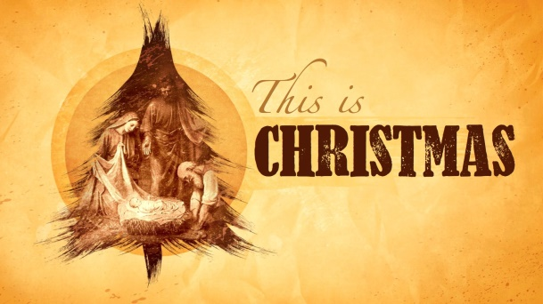

**Christmas Schedule**

**His Kidz Family Night**

Sunday, December 10, 5:30 pm

**"This is Christmas" A Concert of Praise**

Saturday, December 16, 6:00 pm

Sunday, December 17, 6:00 pm

**Christmas Eve Morning Service**

Sunday Morning, December 24, 9:15 am & 10:45 am



**Christmas Schedule**

**His Kidz Family Night**

Sunday, December 10, 5:30 pm

**"This is Christmas" A Concert of Praise**

Saturday, December 16, 6:00 pm

Sunday, December 17, 6:00 pm

**Christmas Eve Morning Service**

Sunday Morning, December 24, 9:15 am & 10:45 am