December 18, 2016 Faith Baptist Church
The Holy Spirit - Indwelling and Empowering Matt Culbertson, Senior Pastor

"The Fruit of Peace"
Galatians 5:22-25

The Fruit of the Spirit
(Galatians 5:22-25)

Love → Agape; compassionate, giving, serving, and unconditional love

Joy → Inner contentment expressed in outward cheerfulness

Peace → Inner _________________ expressed in confident
__________________
(Mark 4:37-39; John 14:25-27)

1. Understand what Peace is ___________.
(John 14:31; John 16:33; Mark 4:40)

2. Peace will be expressed in ____________________.
(Hebrews 11:1)

- Faith to rest in God's ________________ (John 14:17)

- Faith to walk in God's _________________ (John 14:11-12)

- Faith to believe and obey His _______________ (John 14:13-15)

- Faith to love others as God loves us (Matthew 5:9)

3. Accept Peace as God's gift, given to us by Jesus, the
________________ of ________________.
(Isaiah 9:6; Luke 2:14; Romans 5:8-11; 2 Corinthians 5:17-21)

December 18, 2016 Faith Baptist Church
The Holy Spirit - Indwelling and Empowering Matt Culbertson, Senior Pastor

"The Fruit of Peace"
Galatians 5:22-25

The Fruit of the Spirit
(Galatians 5:22-25)

Love → Agape; compassionate, giving, serving, and unconditional love

Joy → Inner contentment expressed in outward cheerfulness

Peace → Inner _________________ expressed in confident
__________________
(Mark 4:37-39; John 14:25-27)

1. Understand what Peace is ___________.
(John 14:31; John 16:33; Mark 4:40)

2. Peace will be expressed in ____________________.
(Hebrews 11:1)

- Faith to rest in God's ________________ (John 14:17)

- Faith to walk in God's _________________ (John 14:11-12)

- Faith to believe and obey His _______________ (John 14:13-15)

- Faith to love others as God loves us (Matthew 5:9)

3. Accept Peace as God's gift, given to us by Jesus, the
________________ of ________________.
(Isaiah 9:6; Luke 2:14; Romans 5:8-11; 2 Corinthians 5:17-21)

Join us this Christmas
season as we celebrate the
King of Kings!

December 18th, 5:30pm
“Happy Birthday Jesus” Family Night

December 24th, 5:30pm
Christmas Eve Candlelight Service

December 25th, 10:00am
One Worship Service

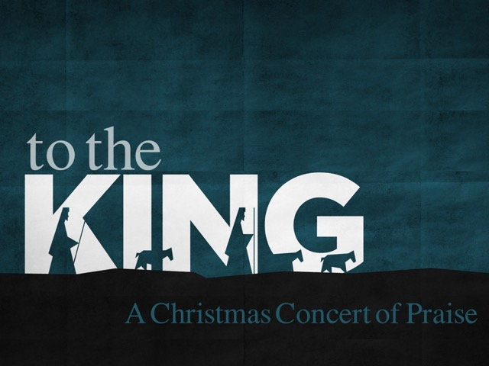

Join us this Christmas
season as we celebrate the
King of Kings!

December 18th, 5:30pm
“Happy Birthday Jesus” Family Night

December 24th, 5:30pm
Christmas Eve Candlelight Service

December 25th, 10:00am
One Worship Service

