February 12, 2017 Faith Baptist Church The Holy Spirit - Indwelling and Empowering Matt Culbertson, Senior Pastor

"Self-Control"
Galatians 5:22-25

The Fruit of the Spirit
(John 14:16-17; Galatians 5:16-25)

- Love (1 John 4:7-10)
- Joy (John 15:10-11)
- Peace (John 16:33)
- Patience (2 Peter 3:9)
- Kindness (Ephesians 4:31-5:2)
- Goodness (Galatians 6:9-10)
- Faithfulness (Hebrews 11:6)
- Meekness (Colossians 3:12-14)
- Self-Control (2 Peter 1:2-7; Luke 9:23-26)

1. Deny ___________________
(Luke 9:23-24; Galatians 5:17; Romans 13:14; James 4:7-8)

2. Take up our ________________
(Luke 9:23, 25; Galatians 2:20; Romans 6:6-7,11-13)

3. Follow _________________
(Luke 9:23, 26, 57-62; John 10:10, 27)

- How does my life measure up to the Fruit of the Spirit?
- How does my flesh war against the specific characteristics?
- How will I know I am gaining victory?
(Galatians 5:22-26)

February 12, 2017 Faith Baptist Church The Holy Spirit - Indwelling and Empowering Matt Culbertson, Senior Pastor

"Self-Control"
Galatians 5:22-25

The Fruit of the Spirit
(John 14:16-17; Galatians 5:16-25)

- Love (1 John 4:7-10)
- Joy (John 15:10-11)
- Peace (John 16:33)
- Patience (2 Peter 3:9)
- Kindness (Ephesians 4:31-5:2)
- Goodness (Galatians 6:9-10)
- Faithfulness (Hebrews 11:6)
- Meekness (Colossians 3:12-14)
- Self-Control (2 Peter 1:2-7; Luke 9:23-26)

1. Deny ___________________
(Luke 9:23-24; Galatians 5:17; Romans 13:14; James 4:7-8)

2. Take up our ________________
(Luke 9:23, 25; Galatians 2:20; Romans 6:6-7,11-13)

3. Follow _________________
(Luke 9:23, 26, 57-62; John 10:10, 27)

- How does my life measure up to the Fruit of the Spirit?
- How does my flesh war against the specific characteristics?
- How will I know I am gaining victory?
(Galatians 5:22-26)

Prayer Revival Service
Jeremiah 29:12-14
Sunday, February 26
Featuring Guest Speaker: Rev. Gary Frost

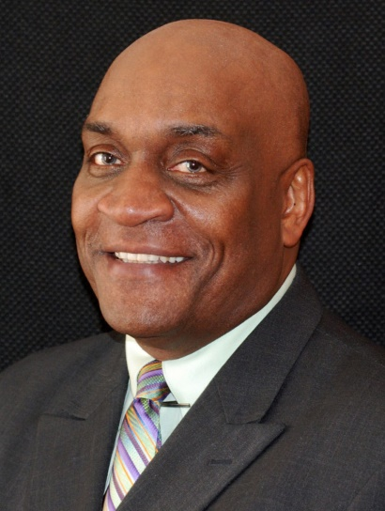

Rev. Frost will be preaching both services on Sunday morning, and leading a special time of worship and prayer on Sunday evening @ 6:00pm

Everyone welcome - Childcare will be provided. To learn more about Gary and his ministry with Mission America Coalition visit their website at missionamerica.org

Then you will call upon Me and go and pray to Me, and I will listen to you. Jeremiah 29:12

Prayer Revival Service
Jeremiah 29:12-14
Sunday, February 26
Featuring Guest Speaker: Rev. Gary Frost

Rev. Frost will be preaching both services on Sunday morning, and leading a special time of worship and prayer on Sunday evening @ 6:00pm

Everyone welcome - Childcare will be provided. To learn more about Gary and his ministry with Mission America Coalition visit their website at missionamerica.org

Then you will call upon Me and go and pray to Me, and I will listen to you. Jeremiah 29:12

