February 19, 2017 Faith Baptist Church
Matt Culbertson, Senior Pastor

"The Greatest Sin"

The Greatest Sin : __________________ _____________
(Deuteronomy 32:18; Psalm 106:21; Jeremiah 3:21)

Remember the Lord
(Psalm 20:7-9; Psalm 105:1, 4-5)

1. We remember God when we _______________ Him in all our ways.
(Psalm 106:13-15; Jeremiah 2:13; Jeremiah 29:11-13)

2. We remember God when we ______________ of sin and failure.
(Psalm 106:6-8; Jeremiah 3:21; Joel 2:13)

3. We remember God when we walk according to His _____________.
(Psalm 106:24-25; Jeremiah 9:13; Proverbs 3:5-6)

4. We remember God when we walk in _______________.
(Judges 3:7; Psalm 106:34-40; 1 Timothy 1:5; 2 Timothy 2:22)

5. We remember God when we give Him our ____________.
(Isaiah 17:10; Jeremiah 18:15; Deuteronomy 26:10; Proverbs 3:9)

6. We remember God when our lives give Him ______________.
(Psalm 106:1-2; 1 Chronicles 16:8-15)

February 19, 2017 Faith Baptist Church
Matt Culbertson, Senior Pastor

"The Greatest Sin"

The Greatest Sin : __________________ _____________
(Deuteronomy 32:18; Psalm 106:21; Jeremiah 3:21)

Remember the Lord
(Psalm 20:7-9; Psalm 105:1, 4-5)

1. We remember God when we _______________ Him in all our ways.
(Psalm 106:13-15; Jeremiah 2:13; Jeremiah 29:11-13)

2. We remember God when we ______________ of sin and failure.
(Psalm 106:6-8; Jeremiah 3:21; Joel 2:13)

3. We remember God when we walk according to His _____________.
(Psalm 106:24-25; Jeremiah 9:13; Proverbs 3:5-6)

4. We remember God when we walk in _______________.
(Judges 3:7; Psalm 106:34-40; 1 Timothy 1:5; 2 Timothy 2:22)

5. We remember God when we give Him our ____________.
(Isaiah 17:10; Jeremiah 18:15; Deuteronomy 26:10; Proverbs 3:9)

6. We remember God when our lives give Him ______________.
(Psalm 106:1-2; 1 Chronicles 16:8-15)

Prayer Revival Service
Jeremiah 29:12-14
Sunday, February 26
Featuring Guest Speaker: Rev. Gary Frost

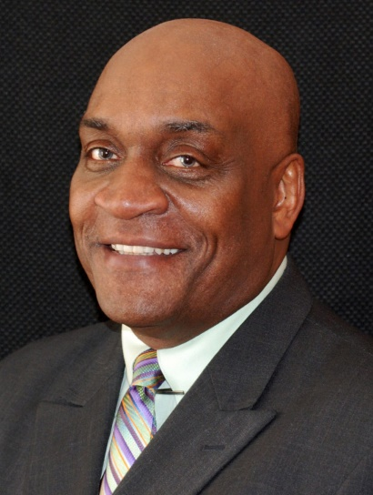

Rev. Frost will be preaching both services on Sunday morning, and leading a special time of worship and prayer on Sunday evening @ 6:00pm

Everyone welcome - Childcare will be provided. To learn more about Gary and his ministry with Mission America Coalition visit their website at missionamerica.org

Then you will call upon Me and go and pray to Me, and I will listen to you. Jeremiah 29:12

Prayer Revival Service
Jeremiah 29:12-14
Sunday, February 26
Featuring Guest Speaker: Rev. Gary Frost

Rev. Frost will be preaching both services on Sunday morning, and leading a special time of worship and prayer on Sunday evening @ 6:00pm

Everyone welcome - Childcare will be provided. To learn more about Gary and his ministry with Mission America Coalition visit their website at missionamerica.org

Then you will call upon Me and go and pray to Me, and I will listen to you. Jeremiah 29:12

