February 26, 2017 Faith Baptist Church
Rev. Gary Frost, Guest Speaker

"Sermon Notes"

February 26, 2017 Faith Baptist Church
Rev. Gary Frost, Guest Speaker

"Sermon Notes"

Prayer Revival Service
Jeremiah 29:12-14
Sunday, February 26
Featuring Guest Speaker: Rev. Gary Frost

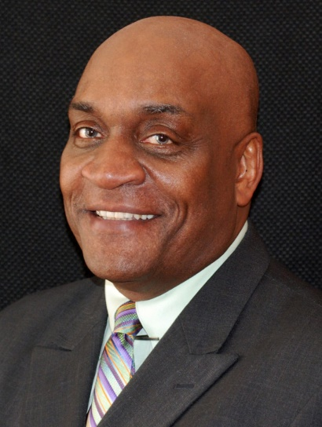

Rev. Frost will be preaching both services on Sunday morning, and leading a special time of worship and prayer on Sunday evening @ 6:00pm

Everyone welcome - Childcare will be provided. To learn more about Gary and his ministry with Mission America Coalition visit their website at missionamerica.org

Then you will call upon Me and go and pray to Me, and I will listen to you. Jeremiah 29:12

Prayer Revival Service
Jeremiah 29:12-14
Sunday, February 26
Featuring Guest Speaker: Rev. Gary Frost

Rev. Frost will be preaching both services on Sunday morning, and leading a special time of worship and prayer on Sunday evening @ 6:00pm

Everyone welcome - Childcare will be provided. To learn more about Gary and his ministry with Mission America Coalition visit their website at missionamerica.org

Then you will call upon Me and go and pray to Me, and I will listen to you. Jeremiah 29:12

