February 5, 2017 Faith Baptist Church The Holy Spirit - Indwelling and Empowering Matt Culbertson, Senior Pastor

"Meekness"
Galatians 5:22-25

The Fruit of the Spirit is...
(Galatians 5:22-25)

"The Meek will inherit the earth"
(Matthew 5:5; Matthew 11:29; Colossians 3:12-14; Titus 3:1-2)

* Meekness is inward _________________, developed by _____________________ to God, expressed in gentleness, humility, and ___________________.
(Numbers 12:3, 8; Ephesians 4:1-2; James 3:13-19)

Walking in the "meekness of wisdom"
(Proverbs 9:10; 15:33)

1. Examine our _______________. (James 3:14-17)

2. Be a __________________________. (James 3:17; Matthew 5:9)

3. Practice _________________________. (James 3:17; Colossians 3:12)

4. Be "willing to __________________". (James 3:17; Philippians 2:2-5)

5. Be quick to _____________________. (James 3:17; Romans 12:17-19)

6. Value all persons as _______________ by God. (James 3:17; 2 Peter 3:9)

7. Live a life of _________________ and surrender. (James 3:17; Romans 12:9)

8. Yield the fruit of ______________________ in peace. (James 3:13, 18)

February 5, 2017 Faith Baptist Church The Holy Spirit - Indwelling and Empowering Matt Culbertson, Senior Pastor

"Meekness"
Galatians 5:22-25

The Fruit of the Spirit is...
(Galatians 5:22-25)

"The Meek will inherit the earth"
(Matthew 5:5; Matthew 11:29; Colossians 3:12-14; Titus 3:1-2)

* Meekness is inward _________________, developed by _____________________ to God, expressed in gentleness, humility, and ___________________.
(Numbers 12:3, 8; Ephesians 4:1-2; James 3:13-19)

Walking in the "meekness of wisdom"
(Proverbs 9:10; 15:33)

1. Examine our _______________. (James 3:14-17)

2. Be a __________________________. (James 3:17; Matthew 5:9)

3. Practice _________________________. (James 3:17; Colossians 3:12)

4. Be "willing to __________________". (James 3:17; Philippians 2:2-5)

5. Be quick to _____________________. (James 3:17; Romans 12:17-19)

6. Value all persons as _______________ by God. (James 3:17; 2 Peter 3:9)

7. Live a life of _________________ and surrender. (James 3:17; Romans 12:9)

8. Yield the fruit of ______________________ in peace. (James 3:13, 18)

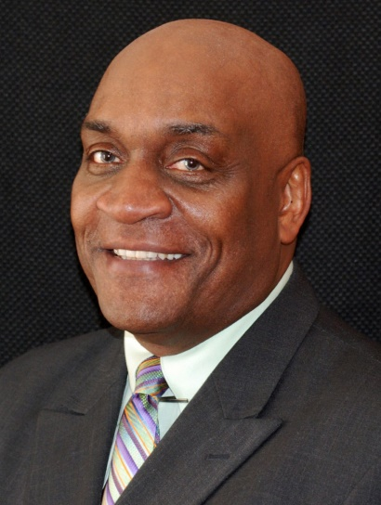

Prayer Revival Service
Sunday, February 26
Featuring Guest Speaker: Rev. Gary Frost

Rev. Frost will be preaching both services on Sunday morning, and leading a special time of worship and prayer on Sunday evening @ 6:00pm

Everyone welcome - Childcare will be provided. To learn more about Gary and his ministry with Mission America Coalition visit their website at missionamerica.org

Prayer Revival Service
Sunday, February 26
Featuring Guest Speaker: Rev. Gary Frost

Rev. Frost will be preaching both services on Sunday morning, and leading a special time of worship and prayer on Sunday evening @ 6:00pm

Everyone welcome - Childcare will be provided. To learn more about Gary and his ministry with Mission America Coalition visit their website at
missionamerica.org

