March 6, 2016 Faith Baptist Church
Hebrews: Consider Jesus Matt Culbertson-Senior Pastor

“Enter His Rest”
Hebrews 3-4:13

God has promised and provided for our ________________.
(Hebrews 4:1-10; John 10:10)

- We appropriate _____________ rest as _______________ rest!
(Hebrews 4:1-3, 9-11)

- We must hold on to ___________________
(Hebrews 3:6, 14)

- We must not waiver in _______________________
(Hebrews 3:8-15)

- We must listen and ________________ His voice (Hebrews 3:7, 15)

- We will remain in His rest by ______________________ His word.
(Hebrews 4:12-13; Proverbs 3:5-6; John 15:9-11, 14; Matthew 11:28-30)

March 6, 2016 Faith Baptist Church
Hebrews: Consider Jesus Matt Culbertson-Senior Pastor

“Enter His Rest”
Hebrews 3-4:13

God has promised and provided for our ________________.
(Hebrews 4:1-10; John 10:10)

- We appropriate _____________ rest as _______________ rest!
(Hebrews 4:1-3, 9-11)

- We must hold on to ___________________
(Hebrews 3:6, 14)

- We must not waiver in _______________________
(Hebrews 3:8-15)

- We must listen and ________________ His voice (Hebrews 3:7, 15)

- We will remain in His rest by ______________________ His word.
(Hebrews 4:12-13; Proverbs 3:5-6; John 15:9-11, 14; Matthew 11:28-30)

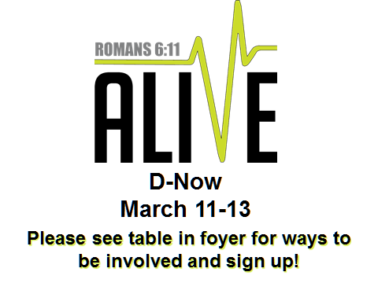
EASTER SCHEDULE

Good Friday Service
March 25th, 6:30 pm

Resurrection Sunday Services
March 27th

Worship: 8:00 am

Worship/Bible Study: 9:15 and 10:45 am
(Activities for Birth - 6th grade at all Sunday Morning services)
EASTER SCHEDULE

Good Friday Service
March 25th, 6:30 pm

Resurrection Sunday Services
March 27th

Worship: 8:00 am

Worship/Bible Study: 9:15 and 10:45 am
(Activities for Birth - 6th grade at all Sunday Morning services)

