April 30, 2017 Faith Baptist Church
Romans: The Gospel of Grace Matt Culbertson, Senior Pastor

"The Gospel"
Romans 1:16-17

Paul, Unashamed of the Gospel
(Romans 1:16-17)

What is the Gospel?*

__od's character
(Isaiah 43:15; John 3:16)

__ffense of Sin
(Romans 5:12; 3:23)

__ufficicency of Christ
(Romans 1:1-6; 1 Corinthians 15:1-4; John 1:29)

__ersonal response
(Acts 3:19; 4:12; Romans 1:16; Ephesians 2:8-9)

__ternal urgency
(John 14:2-4; 2 Thessalonians 1:8-9)

__ife transformation
(Romans 1:17; Galatians 2:29)

How do we live the Gospel?
(1 Corinthians 1:18)

1. Be ___________________ (Romans 1:8)

2. Be ___________________ (Romans 1:9-10)

3. Be ______________ filled (Romans 1:11-12)

4. Be ___________________ to go and share (Romans 1:13-15)

5. Be ___________________ (Romans 1:16-17)

*Gospel acrostic, David Platt, Secret Church 2016
April 30, 2017 Faith Baptist Church
Romans: The Gospel of Grace Matt Culbertson, Senior Pastor

"The Gospel"
Romans 1:16-17

Paul, Unashamed of the Gospel
(Romans 1:16-17)

What is the Gospel?*

__od's character
(Isaiah 43:15; John 3:16)

__ffense of Sin
(Romans 5:12; 3:23)

__ufficicency of Christ
(Romans 1:1-6; 1 Corinthians 15:1-4; John 1:29)

__ersonal response
(Acts 3:19; 4:12; Romans 1:16; Ephesians 2:8-9)

__ternal urgency
(John 14:2-4; 2 Thessalonians 1:8-9)

__ife transformation
(Romans 1:17; Galatians 2:29)

How do we live the Gospel?
(1 Corinthians 1:18)

1. Be ___________________ (Romans 1:8)

2. Be ___________________ (Romans 1:9-10)

3. Be ______________ filled (Romans 1:11-12)

4. Be ___________________ to go and share (Romans 1:13-15)

5. Be ___________________ (Romans 1:16-17)

*Gospel acrostic, David Platt, Secret Church 2016
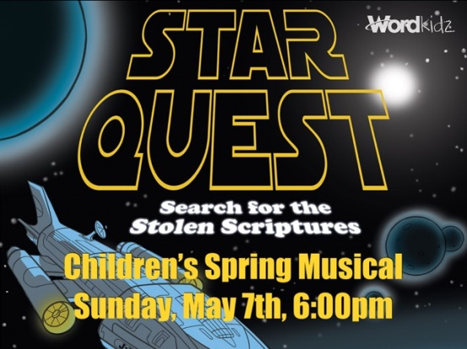
Closing Program - Sunday, April 30 @ 5:30
Dessert Bake Off/Fellowship
May 21: 2017-2018 Budget Presentation,
Question & Answer
May 21 @ 6:00 pm
Closing Program - Sunday, April 30 @ 5:30
Dessert Bake Off/Fellowship
May 21: 2017-2018 Budget Presentation,
Question & Answer
May 21 @ 6:00 pm

