May 7, 2017 Faith Baptist Church
Romans: The Gospel of Grace Matt Culbertson, Senior Pastor

"Guilty Before God"
Romans 1:18-2:16

The "Courtroom" of God

1. We are __________________ before God
(Romans 1:18; 2:1)

- "The wrath of God" = God's anger toward and ____________________ of sin.

2. We are under God's ________________________.
(Romans 1:32)

- Death
(Romans 5:15)

- Suffering
(Romans 8:18)

- Sin's Blindness
(Romans 1:24)

3. We can receive God's ____________________.
(Romans 2:4, 6-7)

*Mercy trumps judgement!

- God is _____________________
(2 Peter 3:9)

- God forgives and ___________________
(1 John 1:9)

- God gives New __________________
(1 Corinthians 6:9-11)

4. Our only hope is in ______________ ________________
(Romans 2:11-16, 6:23)

May 7, 2017 Faith Baptist Church
Romans: The Gospel of Grace Matt Culbertson, Senior Pastor

"Guilty Before God"
Romans 1:18-2:16

The "Courtroom" of God

1. We are __________________ before God
(Romans 1:18; 2:1)

- "The wrath of God" = God's anger toward and ____________________ of sin.

2. We are under God's ________________________.
(Romans 1:32)

- Death
(Romans 5:15)

- Suffering
(Romans 8:18)

- Sin's Blindness
(Romans 1:24)

3. We can receive God's ____________________.
(Romans 2:4, 6-7)

*Mercy trumps judgement!

- God is _____________________
(2 Peter 3:9)

- God forgives and ___________________
(1 John 1:9)

- God gives New __________________
(1 Corinthians 6:9-11)

4. Our only hope is in ______________ ________________
(Romans 2:11-16, 6:23)

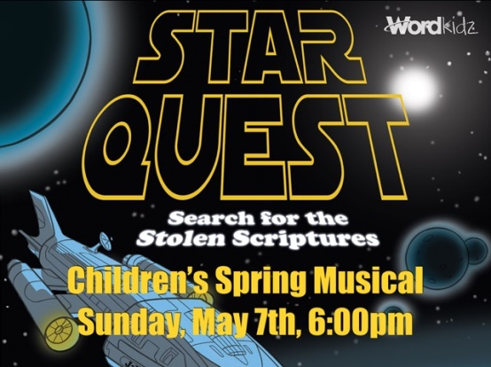
TONIGHT!!
TONIGHT!!
May 21 @ 6:00 pm
May 21: 2017-2018 Budget Presentation,
Question & Answer
May 21: 2017-2018 Budget Presentation,
Question & Answer
May 21 @ 6:00 pm

