July 17, 2016 Faith Baptist Church
The Lord's Prayer - Connecting With God Matt Culbertson, Senior Pastor

“Our Father...”
Matthew 6:5-13

Prayer is connecting with God
(Matthew 6:8; John 15:7-8)

- 3 Words to guide our journey:
Relationship, Seeking, and Alignment

"Our Father..."
(Matthew 6:9; Mark 14:35-36; Romans 8:15-16)

- God is a _______________________ Father
(1 Peter 5:7)

- God is a _______________________ Father
(James 1:17)

- God is a _________________ Father
(Psalm 34:18)

"Our Father in Heaven,"
(Matthew 6:9; Psalm 115:3)

- God is a ______________________ Father
(Matthew 6:32-33; 7:11)

"Our Father...Hallowed be Your Name."
(Matthew 6:9; John 17:5-6)

- God is a ______________________ Father
(John 17:26)

So;
- We must _____________________Him

- We must _____________________ Him

- We must _____________________ Him
(Ephesians 3:14-21)
July 17, 2016 Faith Baptist Church
The Lord's Prayer - Connecting With God Matt Culbertson, Senior Pastor

“Our Father...”
Matthew 6:5-13

Prayer is connecting with God
(Matthew 6:8; John 15:7-8)

- 3 Words to guide our journey:
Relationship, Seeking, and Alignment

"Our Father..."
(Matthew 6:9; Mark 14:35-36; Romans 8:15-16)

- God is a _______________________ Father
(1 Peter 5:7)

- God is a _______________________ Father
(James 1:17)

- God is a _________________ Father
(Psalm 34:18)

"Our Father in Heaven,"
(Matthew 6:9; Psalm 115:3)

- God is a ______________________ Father
(Matthew 6:32-33; 7:11)

"Our Father...Hallowed be Your Name."
(Matthew 6:9; John 17:5-6)

- God is a ______________________ Father
(John 17:26)

So;
- We must _____________________Him

- We must _____________________ Him

- We must _____________________ Him
(Ephesians 3:14-21)

Call to Pray
Faith Baptist Church
2016

- July 8 - October 28, Prayer and Fasting Fridays
(Prayer focus sent out each Wednesday, sign-up on Worship Guide tear-off or contact church office.)

- August 11, 7:00-8:00 p.m., Prayer Gathering at Faith Baptist Church. Emphasis on families, children, schools etc.

- September 11, Sunday Morning Worship. Prayer focus for our nation and world.

- October 12, 7:00-8:00p.m., Prayer Gathering at Faith Baptist Church. Emphasis on upcoming election and prayer for revival.
Call to Pray
Faith Baptist Church
2016

- July 8 - October 28, Prayer and Fasting Fridays
(Prayer focus sent out each Wednesday, sign-up on Worship Guide tear-off or contact church office.)

- August 11, 7:00-8:00 p.m., Prayer Gathering at Faith Baptist Church. Emphasis on families, children, schools etc.

- September 11, Sunday Morning Worship. Prayer focus for our nation and world.

- October 12, 7:00-8:00p.m., Prayer Gathering at Faith Baptist Church. Emphasis on upcoming election and prayer for revival.

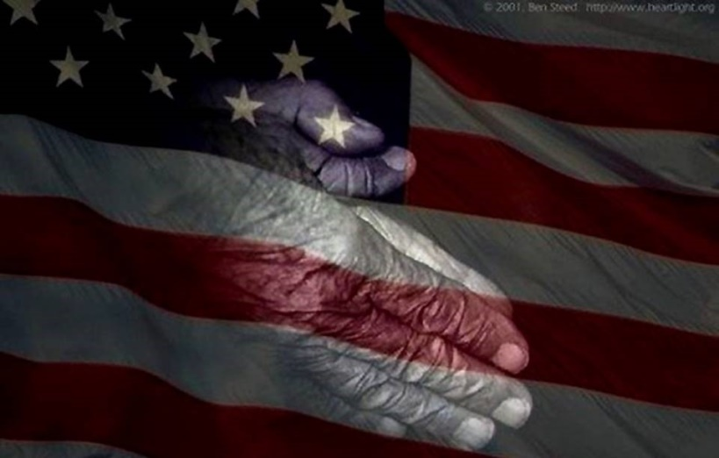
Fundraiser for Summer Student Camp and Mission Trip!
May 22nd, 6:00 pm
An evening of entertainment, fun and fellowship!
Fundraiser for Summer Student Camp and Mission Trip!
May 22nd, 6:00 pm
An evening of entertainment, fun and fellowship!

